Session you are applying for:
(put an X next to your choice)

Oral presentation (15 minutes including questions)
Poster

 | Session 1 | Interaction Protein-Membrane
 | Session 2 | Structural and dynamics insights on membrane protein function
 | Session 3 | Membrane protein Pharmacology
 | Session 4 | Membrane protein: assembly, traffic and signaling
 | Session 5 | Bioanalytical methods to study membrane protein
 | Session 7 | Membrane protein physiology and pathologies
 | Session 8 | Channels
 | Session 9 | Late Breaking Topics

Title
(1 blank line)
A. Author ª, co-authors ª
(1 blank line)
ª (Ex) Molecular Microbiology and Structural Biochemistry, MMSB, University of Lyon, CNRS, UMR5086, Lyon, France.
E-mail: presenting-author@email.fr
(2 blank lines)

Please, enter your abstract here following these instructions: (1 page max)
- Title: Bold, Calibri 14 pt, single-spaced, centered
- Author list: Calibri 12 pt, single-spaced, centered
- The name of the presenting author should be underlined.
- Abstract: Calibri 12 pt, single-spaced, justified.
- References should appear in text by Arabic numerals in square brackets, [1], [2], etc. in order of appearance and should be quoted according to the model below.
(1 blank line)
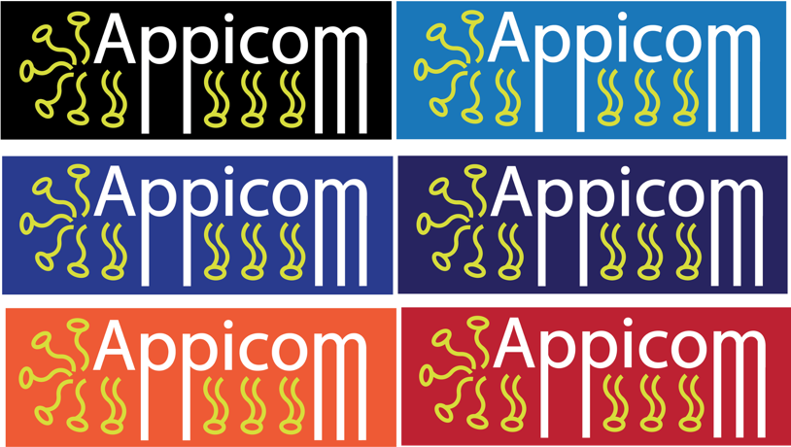
Fig. 1: Figure (and table) captions.

(2 blank lines)

[1] A. Author, co-authors. (year). Title. Journal volume:pages

Your abstract must fit in one page.
For abstract submission, save the file in Word or pdf format as follows: PresentingAuthorName_APPICOM.doc/docx and email it to appicom@listes.ibcp.fr

Please include bellow the session you would like to apply for.

